Scott Tabaka
Instructor: Badri Adhikari
CmpSci 4300 Fall 2019
Due Date: 11/21/2019

Homework #3

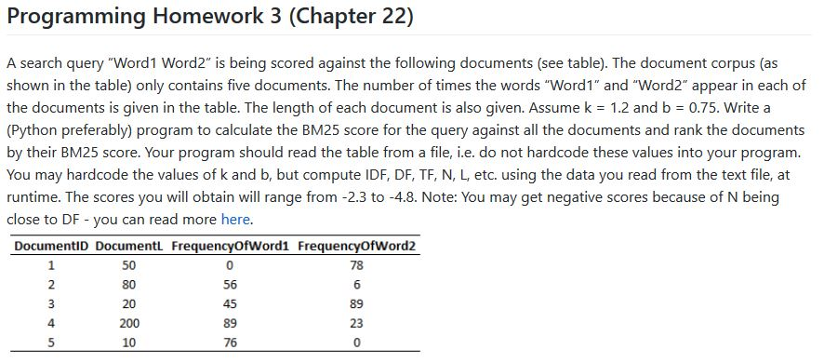

Java code:
import java.io.File;
import java.io.FileNotFoundException;
import java.util.ArrayList;
import java.util.Arrays;
import java.util.List;
import java.util.Scanner;
public class BM25
{
public static void main(String[] args)
{
String filename = "doc1.csv";
List<List<String>> lines = getCSVdata(filename);
int N, word1=2, word2=3;
double k = 1.2, b = 0.75;
double IDF1, IDF2, L, DF1, DF2, BM25W1W2, BM25W1, BM25W2;
N = lines.size();
System.out.println("N: " + N);
L = calculateL(lines,N);
System.out.println("L: " + L);
DF1 = calculateDF(lines, N, word1);
DF2 = calculateDF(lines, N, word2);
System.out.println("DF1: " + DF1);
System.out.println("DF2: " + DF2);
IDF1 = calculateIDF(N,DF1);
IDF2 = calculateIDF(N,DF2);
System.out.println("IDF1: " + IDF1);
System.out.println("IDF2: " + IDF2);
System.out.println();
BM25W1 = calculateBM25(lines,N,k,b,L,IDF1,word1);
BM25W2 = calculateBM25(lines,N,k,b,L,IDF2,word2);
System.out.println("BM25 Word1: " + BM25W1);
System.out.println("BM25 Word2: " + BM25W2);
BM25W1W2 = BM25W1 + BM25W2;
System.out.println();
System.out.println("BM25 Word1&2: " + BM25W1W2);
}
private static double calculateL(List<List<String>> lines, int N)
{
double L = 0;
for(int i = 0; i < N; i++)
{
L += Integer.parseInt(lines.get(i).get(1));
}
L = L/N;
return L;
}
private static double calculateDF(List<List<String>> lines, int N, int wordColumn)
{
double DF = 0;
for(int i = 0; i < N; i++)
{
if(Integer.parseInt(lines.get(i).get(wordColumn)) > 0)
{
DF++;
}
}
return DF;
}
private static double calculateIDF(int N, double DF)
{
return Math.log(((N-DF)+0.5)/(DF+0.5));
}
private static double calculateBM25(List<List<String>> lines, int N, double k, double b, double L, double IDF, int wordColumn)
{
double BM25 = 0;
System.out.println("Word " + (wordColumn-1) + " TF Values:");
for(int i = 0; i < N; i++)
{
double TF = Integer.parseInt(lines.get(i).get(wordColumn));
System.out.println("Document " + (i+1) + " TF: " + TF);
double E = (1-b)+(b*((Integer.parseInt(lines.get(i).get(1)))/L));
BM25 += IDF*((TF*(k+1))/(TF+(k*E)));
}
System.out.println();
return BM25;
}
private static List<List<String>> getCSVdata(String filename)
{
File file= new File(filename);
List<List<String>> lines = new ArrayList<>();
Scanner inputStream;
try{
inputStream = new Scanner(file);
while(inputStream.hasNext())
{
String line = inputStream.next();
String[] values = line.split(",");
lines.add(Arrays.asList(values));
}
inputStream.close();
}catch (FileNotFoundException e)
{
e.printStackTrace();
}
return lines;
}
}

Output:
